Survival in a competitive industry mandates that organizations continually examine who they are and where they are going. Companies must identify their strengths and weaknesses to comprehend how they will tackle what the future may hold. This paper identifies a possible solution as to how any large or mid-size organization can compete with a long-term innovation plan without stifling innovation.

© The Entrepreneur’s Advisor 2016
LinkedIn: Stuart Smith, M.B.A., M.S. Entrepreneurship in Applied Technologies
Innovate or Perish
Do you remember when Blockbuster, Pan AM, Woolworth’s and Sears Roebuck were fixtures in our lives? The last few decades have seen a number of large iconic organizations disappear from everyday conversations. There are any number of reasons organizations fail such as poor financial management, changes in the regulatory landscape or their products and services becoming obsolete. More often than not it is a combination of many factors.
However, for every organization going out of business a new one enters the marketplace. The millennials of today can hardly imagine a life without a smartphone, internet connectivity or some high-tech device. As a result, innovative technology receives a lot of buzz as it seems everyone is racing for that next disruptive technology to change the world. Unfortunately, too many organizations are oblivious to the type of service or process innovation that can be just as impactful as a technology discovery.
Every smart executive knows that change is a fact of life. The question executives must ask is if they want to be ahead of the curve or a follower that hopes that their organization can adapt quickly enough to maintain the status quo. To get ahead of the curve, organizations must commit themselves to having an innovative environment that seeks all forms of innovation to remain competitive and prosper.

Creating the Innovation Desire
Adopting an innovative culture is easier said than done particularly in larger organizations. Given the increasing speed of a changing technology environment, creating and managing an innovative culture without stifling creativity is crucial to the long-term survival.
However, the larger the organization, the more difficult it is to strike a unique balance of the need to become an innovative organization and the challenge of effectively managing the innovative process.
GOOGLE is legendary for innovation but not every organization can follow the lead of companies such as GOOGLE or Apple. Although these companies are known for their development of disruptive products and creativity, the culture and process for innovation were set up when they were small start-up companies. In fact, GOOGLE has shifted away from their legacy of 20% of personal time that could be spent on individual research projects.

Creating the Innovation Desire Continued
An intelligent person learns from the successes and failures of others. With that said, there are certain fundamentals that are consistent across organizations and industries that are re-inventing themselves. The three most important fundamentals are:
- All Senior Management has total buy-in for the long-term changes that need to occur. In other words, innovation cannot be just a buzzword; it must be a mindset throughout the company.
Innovation has to be a company mindset immersed in a collaborative culture.

- The second is that deferred change is a horrible strategy as it only places an organization at a competitive disadvantage and unable to fend off the innovators eating away at chunks of the business.
- No organization should be in a position of only innovating as a result of industry and technology changes. Organizations and industries need to be on the forefront and proactively pursuing innovation.
Lastly, although some innovation can be purchased or developed with technology companies, it is unlikely that anyone will sell you a Blue Ocean idea. Therefore, ideas developed internally are priceless.
Accomplishing change with these three fundamentals in mind requires considerable effort and cultural change.
The ideas discussed in the remainder of this paper outline a potential model that any mid to large size organization could adopt. When set up correctly, the innovation cycle will become a new business as usual (BAU).

Creating the Innovation Vision
Sometimes the hardest part about making changes is organizing and prioritizing your thoughts to get started. The list below mentions the most critical elements for creating an innovative environment.
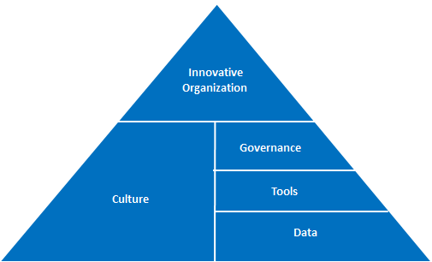

Key Innovation Change Objectives: (listed by priority)
- Be an innovative organization.
If your organization’s innovation is too limited at the moment, the first step must be a commitment to being an innovative organization. This can occur only with total buy-in from all leadership. This is a show stopper if not achieved.

- Create the executive vision and metrics for measurements
  - What are the end goals?
  - Operational focus
  - Strategic growth areas
  - Executive oversight
  - KPI’s – this will give the innovators a common direction and path

Key Innovation Change Objectives: (listed by priority) Continued
- Create the innovation mindset:
No organization should rely on technology or ideas generated from the outside. Moreover, there must be no fear of failure or loss of employment for innovation ideas and attempts. As GOOGLE and other entrepreneurial ventures have discovered, to have a great idea you need lots of them.
The challenge will be to encourage people to bring their ideas forward. However, this will require a cultural change not only in how this is achieved going forward but also with collaboration between the current power silos.

- Change the Culture:
An organization’s culture is rarely defined by one person. It is defined by the type of environment employees work in. Some attributes of an innovate culture include but are not limited to: (How many of these does your organization have?)
  - Dynamic: Embracing continuous change
  - Knowledge exchange: Current and new ideas are shared by everyone
  - Holistic views: Everyone is working toward a greater good and for survival
  - Transparency: This is critical to achieve the proper controls without stifling innovation.
  - Hire right: It will be important to hire people with the right attitude, energy and integrity. It will also be necessary to remove the dragons (people resistant to change) that may interfere or are more concerned with their individual silos.
  - Mentoring: Partnering innovators with experienced entrepreneurs will help achieve greater successes and transparency. The idea is to think through an idea from concept to fruition. Two types of mentors are involved;
    - A level 1 mentor – a person who can help think through the submitted idea.
    - A level 2 mentor – an executive or senior manager to provide guidance and oversight if an idea has been selected for further development.
  - Recognizing cultural change takes time: Disruptive innovation rarely occurs in the short –term. True innovation is a long-term investment of 3-5-10 years or more in people and ideas to obtain the home run payoff. It is similar to starting a business. Few businesses are profitable within the first 3 years.
  - Leadership: Any given organization may not have the leaders in place that they will need in order to create an innovative culture. Skill sets needed include staff development, entrepreneurial backgrounds, communications, and the ability to see the strengths in people.
  - Peer reviews on ideas: Peers provide feedback on ideas as part of the ideation process.
  - Time to create: Freedom to run with an approved idea and time permitted for this.

Key Innovation Change Objectives: (listed by priority) Continued
- Define the Governance:
What will be the platform for submitting, approving and working on ideas? This is the key for managing ideation and information exchange. It is also crucial for executive oversight, mentoring and obtaining employee engagement.
- Define the Tools:
What are the tools to be used for governance and data collection? For example; the selection of a project and monitoring tools. The same tools have to be available to everyone.
- Define Data:
How will the innovation engine work? It is critical that this be set up correctly in the beginning. It is at the bottom of the pyramid because without superior data, the rest of the pyramid will crumble.
  - Where will data be stored?
  - How will data be collected and be made available to use for experimentation, trial and error and traceability?
  - Where will metrics be stored?
  - How will data be transformed into knowledge, intellectual property and know-how?
  - Transparency
Once the mindset, innovative culture and framework as a whole have been set up, the next component is to detail out the ideation.

Ideation in an Innovative Organization

It helps to think of ideation in terms of the Pareto Principle. 80% of investment will go to 20% of the ideas. In other words; if 5 ideas are vetted then 1 idea will receive major funding and 4 may receive some discovery capital. How you arrive at which ideas are to be vetted depends the approach. The approach discussed below involves the entire organization and a designated innovation committee (IC).

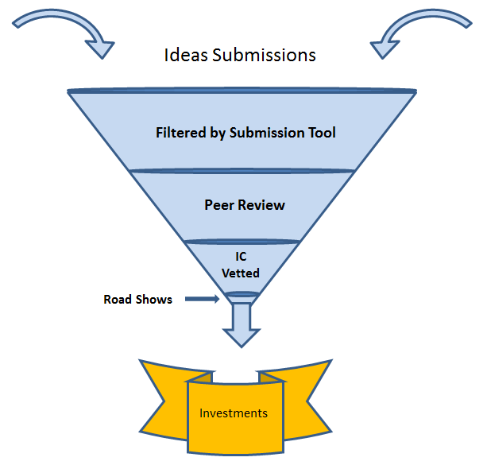

Ideation Submission
Recognizing that an organization needs many ideas, the challenge becomes how to accept and manage them. The primary objectives become:
- Encouraging idea submissions using a standardized submission tool.
- Filtering the good ideas from the weak ideas. By this I mean that half of the ideas that are generated through the employee engagement process are merely a daydream without any substantive thought given to potential applications, markets or business potential.
- Organizations can help management and employee efforts by making implementing as a prerequisite an online training course in Intellectual Property (IP) basics , how the platform works and expectations.
Ideation in an Innovative Organization Continued
Ideation Culling
Of the remaining 50 % of the ideas that have been submitted; the amount of thought behind each idea may vary but the person with the idea believes there may be tangible value. The amount of thought behind an idea can be discovered with a list of leading questions as part of the submission process. This list of questions is unique for each organization.
A peer group then evaluates the ideas for potential using a predefined calculated scorecard for:
- Sensibility
- A check against existing submissions as possible duplicate efforts
- Supplemental application use.
- Possible IP opportunities or concerns
- Relevance to existing or potential markets
- A determination if the idea can create value (not how much)
The peer group is made up of any person(s) wanting to get involved with innovation. The concept here is that ideas that have been submitted into the ideation platform tool are visible to anyone and people can anonymously vote or rank ideas as well as add their thoughts.
Votes, ranks and comments are recorded and tallied for idea viability. The objective is to have a short list of ideas that the innovation committee might consider for vetting. By involving a peer group, employee engagement, transparency, enthusiasm and the quality of ideas are increased. It is a Win-Win for any organization.
The Vetting
This is where true transparency begins and ideas are analyzed and measured against the metrics determined by executive management. The goal of the innovation committee (IC) is to select the 10% of the ideas that have made it through the peer review that will go to the next stage of more serious vetting.
The IC should be a mix of organization leaders, interested parties and a rotating executive who will review the results of the ideas filtered in the peer review. The primary objective of the committee is to further vet the ideas by evaluating them for:
- Operational focus
- Strategic growth areas
- Key metrics
- Potential value to the organization including monetary value, image impact, marketing impact and industry positioning
How often the committee meets depends on the number of ideas in the innovation queue but should probably meet at least once a quarter to avoid good ideas losing their competitive advantage.
If done well, the number of ideas at this stage has probably been narrowed down to 1%.
Ideation in an Innovative Organization Continued
Ideation Decisions – The 1%
After the ideas are narrowed down to the final choices the following should occur:
Each idea creator (innovator) is notified that their idea has been selected for further development and that they will play a key role. This may include:
- Overview and management
- Action planning
- Financial planning
- Resource planning
- Marketing, Delivery, Reporting
I make a point of this because of the need to encourage people to step-up and to develop talent within the walls of every organization wishing to thrive. However, starting a new venture is best done by a team and not just one person.
Should the idea originator not be up to the challenge, the 2nd choice would someone with an entrepreneurial background or as a 3rd choice someone with high energy, a positive attitude and integrity. These are the types of people you should be looking to hire in order to be an innovative organization.
- An executive mentor is assigned to the innovator to help guide them through the learning process of taking an taking an idea from concept to fruition. One person from the innovation committee is also assigned.
- The innovator is given 90 days to present a Road Show (with the help of the IC and executive mentor). The Road Show is the full-fledged (15 minute) why should an investment in this idea take place.
Key points for the innovator
- The innovator should be empowered to act like an entrepreneur act like an entrepreneur and approach the presentation as a start-up company would. They are made responsible for driving their idea forward. Organizations must have extreme patience with the innovator. This person should never feel their job is in jeopardy for two reasons:
- Mistakes happen as this is part of their journey to become experienced leaders. Entrepreneurs learn from mistakes to become stronger.
- These are your future leaders as they will learn about communication, collaboration, networking and countless other skills.
- The IC will make resources available and/or provide additional information if possible such as market analysis, engineering contacts, IP requirements, Enterprise Architecture contacts as well as any other contacts as needed.
The actual ideation process may vary but the seed planted in your organization by having an ideation process will be the cornerstone of future success.
Perception and the Ideation Process
Make the Ideation Process and Culture Changes Business as Usual
One of the most demoralizing aspect staff face is senior organizational leadership that does not listen to ideas and rarely appears to make real change. This results in a perception that senior management is more interested in empire building and self-protection than taking risks inherently associated with ideation.
Because perception is reality; the most critical element of becoming an innovative organization is what occurs after good ideas have come about and have started down the path to business fruition. In a holistic vista, the end game is for the organization to transform into a truly innovative entity. To achieve this objective; the ideation and innovation outlined in the preceding posts needs to become ingrained into the organizational culture.
However, this only works if all the pieces become business as usual and the work flow is dynamic and transparent. Therefore, the last step in creating an innovative culture requires information to be reviewed on a constant basis with adjustments made as conditions and technology change.

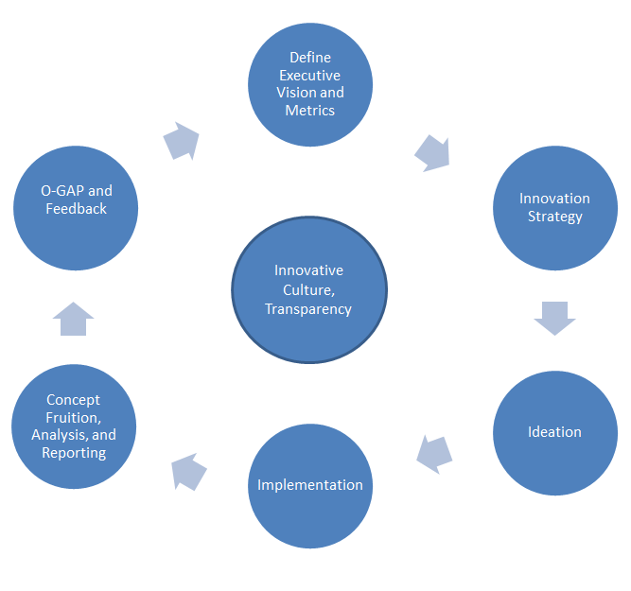

Perception and the Ideation Process Continued
The Operational Gap (O-Gap)
In its most simplistic form the O-Gap is the review of what is working and what is not working. It is the final opportunity to determine how the innovation framework is best operationalized and optimized. Things that are working may be targeted for tinkering and things that are not working are removed. It is important to note that O-Gap analysis includes both people and processes.
You can see in the chart above that the entire innovation process is much like any other work flow. After the vision has been defined and a mechanism has been set in place, a good organization will constantly review and tweak its performance. Once the review process is in place and the cycle has been repeated a couple of times, your organization will be positioned to stay ahead of the competition.
It is important to understand that getting the process right takes time. It make take a couple of years before the intended innovation environment is established

A Commitment to Innovation is Going to Change Your Organization
Are you wondering if you can pull off changing your organization to be a dynamic, innovative and fun place to work? The answer is yes you can, but it requires considerable thought to the innovative environment you want to create.
Perhaps the biggest challenge facing the CEO when creating an innovative environment is to realize that it will not work if you always have to be the smartest person in the room. This is because organizational change is a collaborative effort and no one person has all the answers. You may have the vision but it is others will bring the idea from concept to fruition.

On the other hand, making a commitment to creating an innovative organization can have some very positive advantages thus creating a legacy for years to come.

10 Advantages of an Innovative Organization
The advantages if the type of innovative system outlines in the preceding articles are implemented include but are not limited to:
- A dynamic and aggressive vision for the long-term future.
- A huge increase in innovative ideas, viable products, new services and cost saving initiatives.
- A managed innovative process that balances ideation with management control without stifling the creative influx of ideas.
- Development of a whole new breed of forward thinking executives, managers and staff.
- Staff loyalty to both fellow employees and the organization. This will reduce turnover, provide career paths, increase staff visibility and boost morale.

10 Advantages of an Innovative Organization Continued
- Positive image that can be used in attracting new talent.
- Establish or re-establish the organization as a leader in the industry.
- Raise the barrier of entry for competitors and competing technologies.
- An increase in the ability to deflect and/or assimilate disruptive technology changes in the industry.
- Establish a positive culture of change.

Potential Risks in Creating an Innovative Organization
Transformative change is not without risks. The concept and implementation will fail without:
- Total buy-in from executive and senior leadership for an innovative culture.
- Commitment to culture change; innovation must be the mindset.
- The identification and removal of dragons.
- Employee engagement which is paramount throughout the process.
- Proper ideation management. You must have a tool that can manage the ideation process including peer review, data, knowledge, O-Gap and reporting requirements.
- Patience: Becoming an innovative organization occurs only after innovation has become business as usual. This is a long-term process of 3-5 years if set up correctly.
- This model is at high risk if executives and executive teams in the organization are only there for the short-term to execute immediate financial impact.

The Globalization of Innovation
Access to ideas and information is no longer the privilege of largest or deep pocketed organizations. Thanks to the Internet, the availability of knowledge to all is leading to the Globalization of Innovation
The change in access to information is great news to innovative minds whose ideas and innovation are being generated in all walks of life across the globe. The days of tech companies and patent hoarders controlling IP and dominating innovation are rapidly becoming irrelevant.
As the globalization of innovation occurs those organizations unable to keep pace will be subject to disruptive changes, lose market share, relevance and eventually perish.
So the final question a CEO or business owner contemplating changing to an innovative organization should ask is:
“What are we waiting for?”

